# Microsoft 365 developer program

To create power pages in personal tenant, please do follow the below procedure.

**Pre-requisites**

* To join the Microsoft 365 Developer Program, First, make sure you have a Microsoft Accounts.

**Step 1 :** Microsoft 365 Developer Program

Microsoft 365 Developer Program includes a Microsoft 365 E5 developer subscription that you can use to create your own sandbox. You can build Microsoft Teams apps, Office Add-ins for Word, Excel, PowerPoint, or Outlook, or SharePoint Add-ins, using Microsoft Graph, the SharePoint Framework, Power Apps, and more.

* Open the Microsoft 365 developer program page by clicking the link below:

<https://developer.microsoft.com/en-us/microsoft-365/dev-program>

* Go to the top right corner and sign in with your Hotmail, Outlook, or Microsoft account information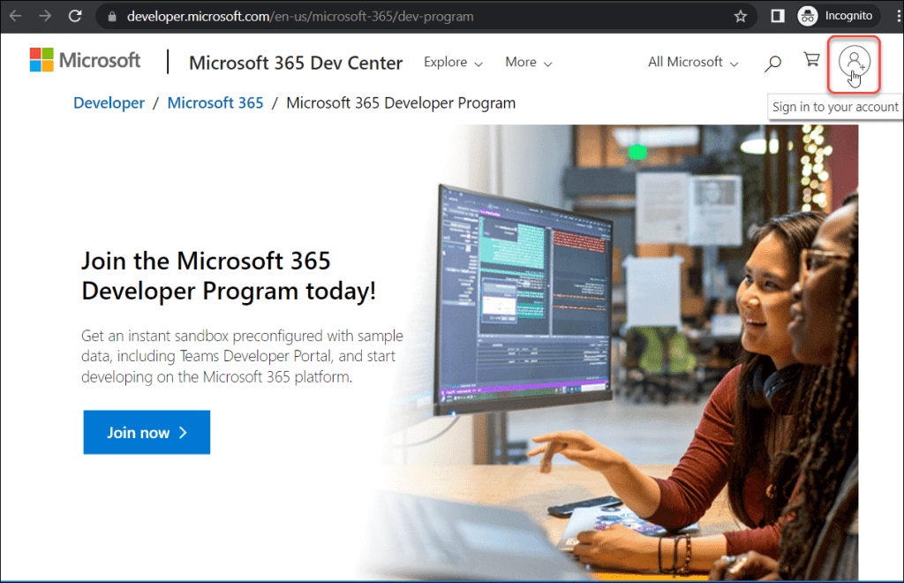
* Provide your Email address and then click on Next.
* Enter your Password and then click on Sign in.
* After successfully signing in, click “Join now” to join the “Microsoft 365 Developer Program today

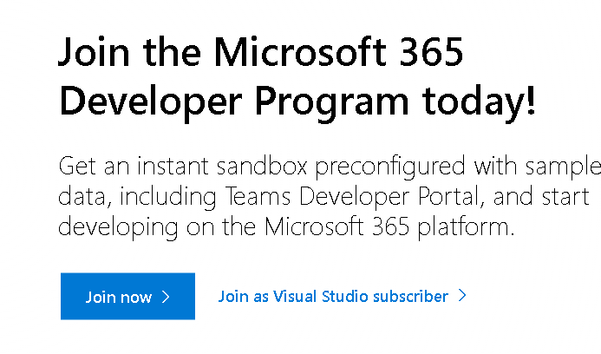

**Step 2:**

* A “Join the Microsoft 365 Developer Program!” page will then display, asking you for details like your Country/Region, Company, Language preference, etc.
* Next, choose and accept the terms and conditions of the Microsoft 365 Developer Program.
* If you’d want to hear from Microsoft about new features and other updates, you can choose the I would like information, tips, and offers about the Microsoft 365 Developer Program check box. Select Next as shown in the screenshot below.

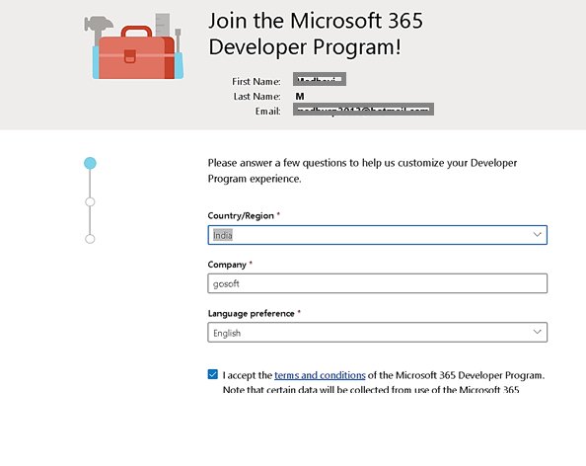

**Step 3:**

* A primary focus page will then show up where you must enter your preferences for Microsoft to personalize your experience.
* Select at least one primary focus as a developer and then click on Next.

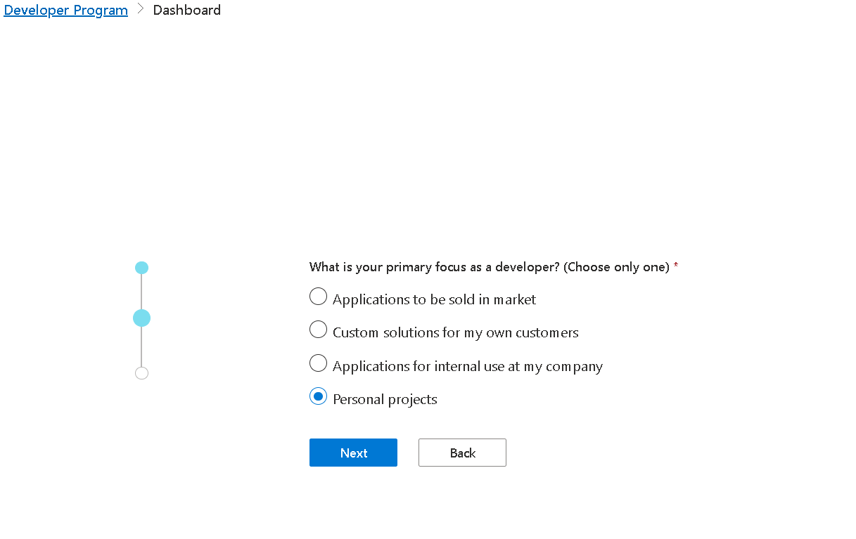

**Step 4:**

On the next page, select what areas of Microsoft 365 development are you interested in. They will show you resources and tools.

Once you selected the areas, click on Save.

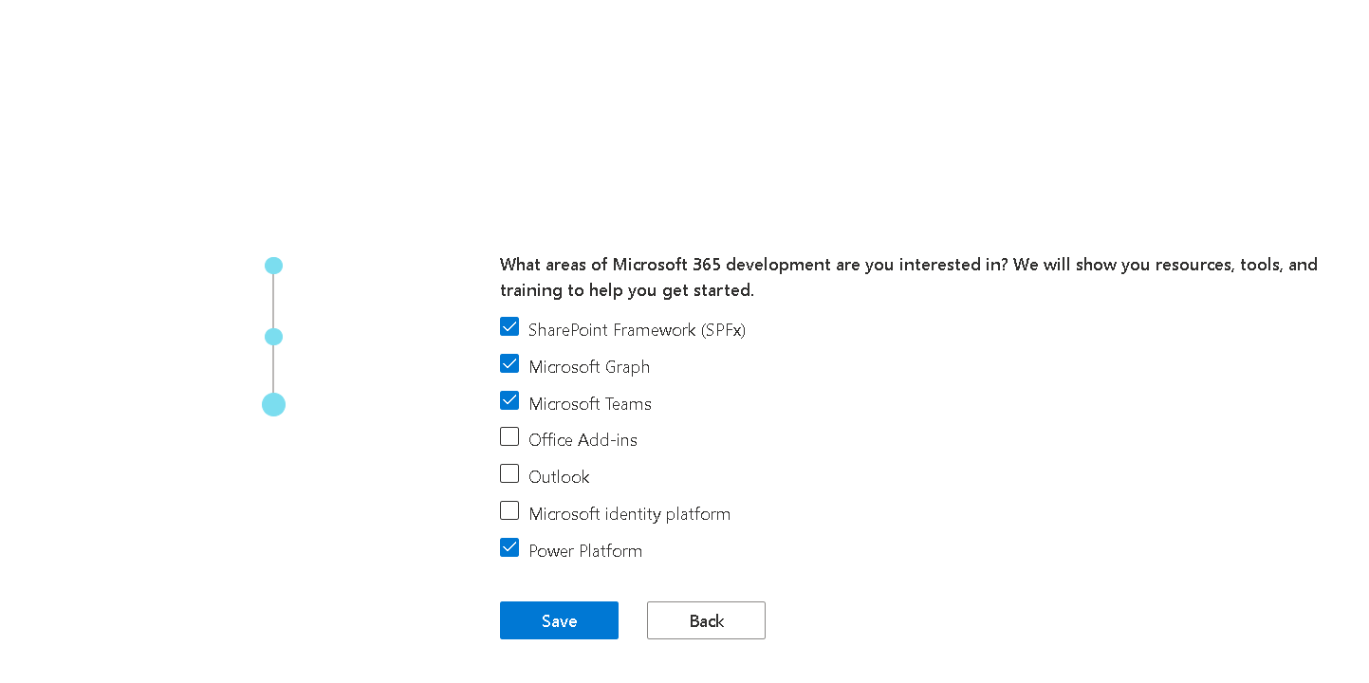

In the **Set up your Microsoft 365 E5 developer subscription** dialog box, choose instant sandbox, and then choose **Next**.

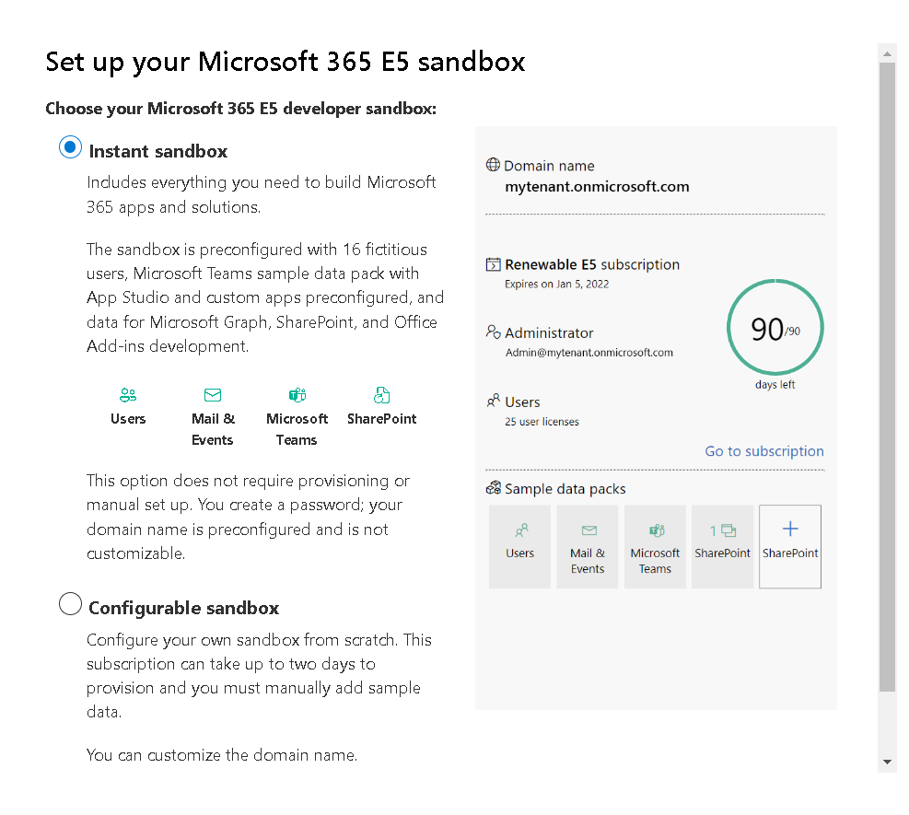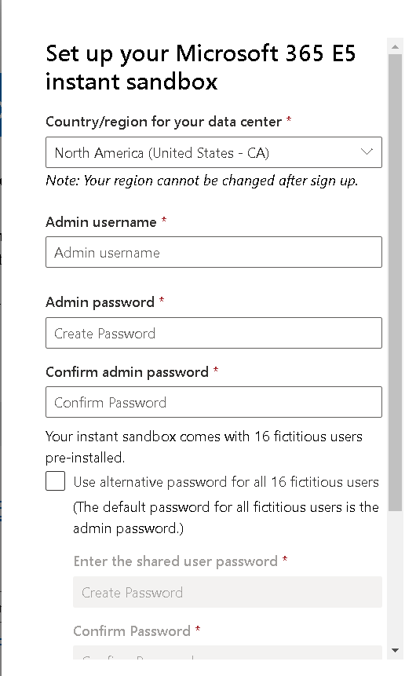

* Choose the **Country/region for your data center**, and provide an **Admin username** and **Admin password**, and optionally an alternative password for your fictitious users, and then choose **Continue**
* Provide a valid cell phone number and choose **Send code**. Enter the code that you receive, and then choose **Set up**.

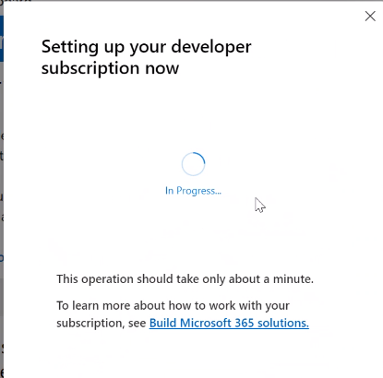

**Step 5:**

* Your Microsoft 365 developer subscription is now complete and available for free use for 90 days.
* Click on the Go to subscription link to sign into the developer account.

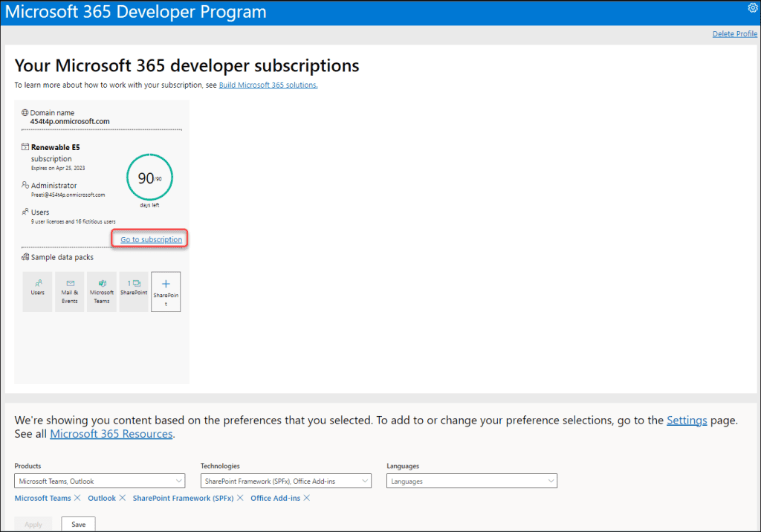

* It will reroute to the Microsoft Sign-in window below, where you will be prompted to enter your password. After entering the admin password
* Select Sign in. You need to sign in with admin account

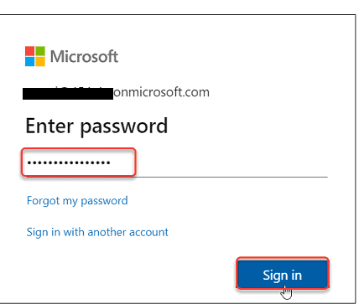

* The next Microsoft window may appear to protect your account as in the image below. If it comes, then click on Ask Later (14 days until this is required). Select Next.

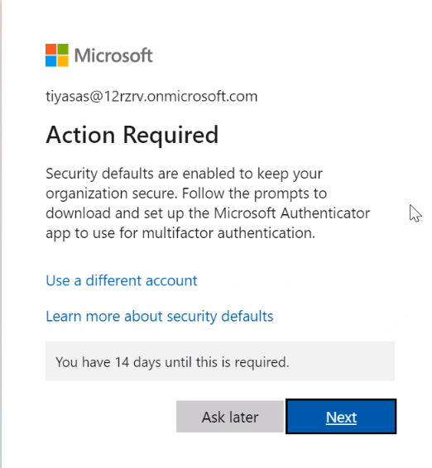

**Step 2: Creating the Power Pages**

Power Pages offers a free 30-day trial. After a quick sign-up, you will have access to many of the key features of Power Pages. You can use the trial to create trial sites and evaluate them by using sample data, and even try out your own customer data

**To sign up for the trial**

1. Go to [https://powerpages.microsoft.com](https://powerpages.microsoft.com/) , and then select **Try it for free**.

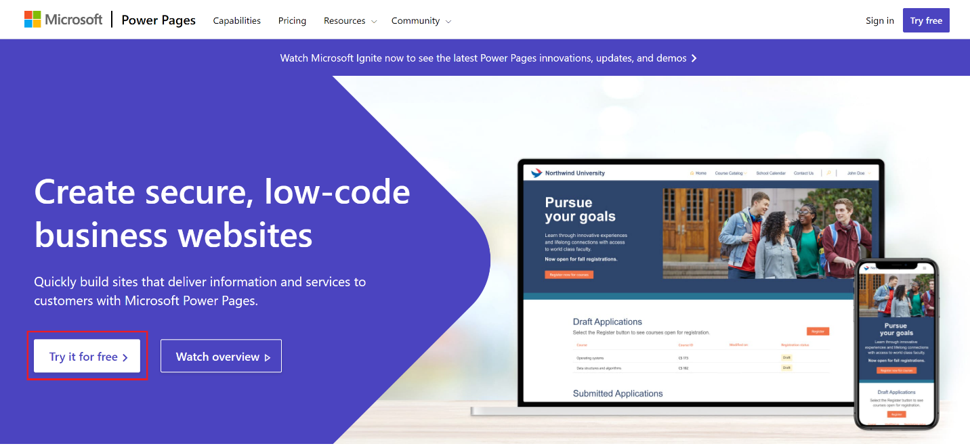

* Click Get started

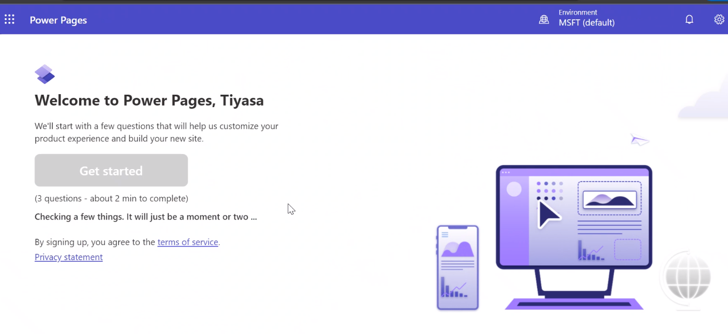

* Select the any available templates.
* After you finalize the template of your choice, select **Choose this template**.
* You can provide a name for your site and site web address as needed.

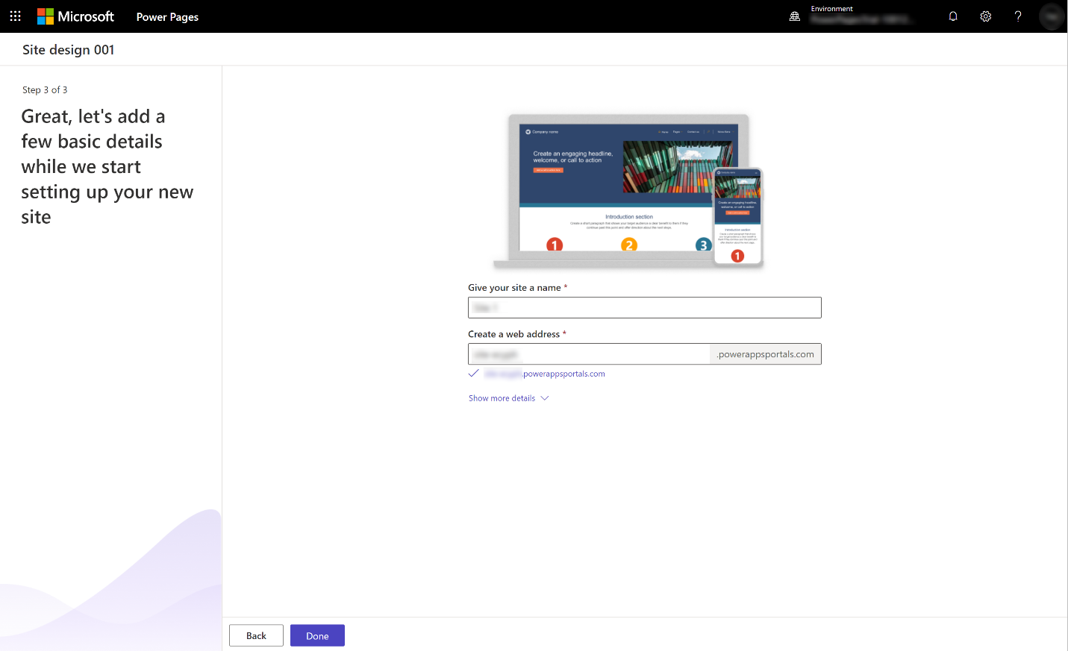

* After you've added all required details, select **Done**.
* The process will take a few moments to set up your site.

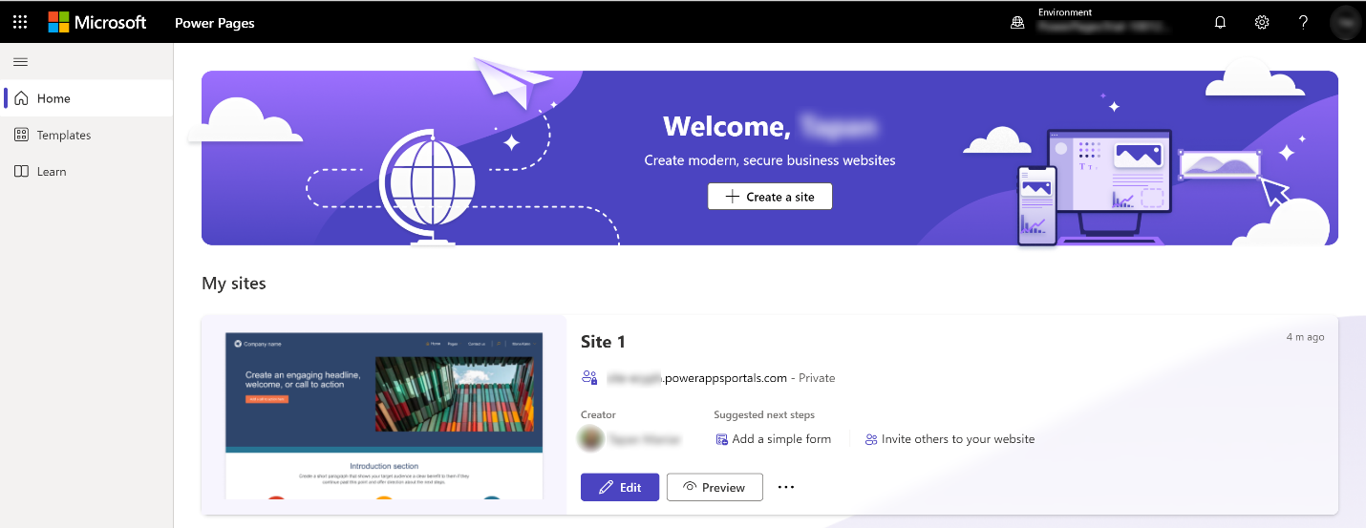

* Click on Edit and modify the pages, after modification you can click on Preview

